**A**

**PROJECT REPORT**

**ON**

**VIRTUAL FARMING ASSISTANT**

**SUBMITTED BY**

Mr. Hardik Kanjariya

Mr. Rahul Kanjariya

**ACADEMIC YEAR 2022-23**

**T.Y B.C.A. SEM - 5**

**UNDER THE GUIDANCE OF**

Mr. Shaunak Purohit

**SMT. C.Z.M GOSRANI B.C.A. COLLEGE**

**JAMNAGAR**

**SUBMITTED TO**



**SAURASHTRA UNIVERSITY**

**RAJKOT**

**A**

**PROJECT REPORT**

**ON**

**VIRTUAL FARMING ASSISTANT**

**SUBMITTED BY**

Mr. Hardik Kanjariya

Mr. Rahul Kanjariya

**ACADEMIC YEAR 2022-23**

**T.Y B.C.A. SEM - 5**

**UNDER THE GUIDANCE OF**

Mr. Shaunak Purohit

**SMT. C.Z.M GOSRANI B.C.A. COLLEGE**

**JAMNAGAR**

**SUBMITTED TO**



**SAURASHTRA UNIVERSITY**

**RAJKOT**

# **ABSTRACT**

VFA is a farming technology platform where we work with farmers directly. We at VFA follow our mission of bridging the gap between technology and agriculture in India with a vision to reach out to maximum Indian farmers.

We support farmers to ***“Grow efficiently, Grow more”*** through the systematic implementation of scientific techniques by providing critical information at appropriate times and regular monitoring.

At VFA, we understand each farmer’s requirements, we believe every farmer deserves a chance - the chance for a successful future with technology.

# **ACKNOWLEDGEMENT**

We feel great pleasure in submitting this project report as a part of our B.C.A. Semester 5 curriculum. A practical study plays an important role.

For the successful completion of our project, we would especially like to thank our parents for their support and unconditional help. We would also like to thank our Project Guide Meet Thakar for their constant support and help in implementation of this project.

We are also thankful to our Principal Ma'am, Ms. Hetal G. Savla for all the facilities they provided throughout our semester and for encouraging us to take up this activity.

Lastly, we would also like to thank the faculties and staff members of Smt. C.Z.M. Gosrani B.C.A. College, Jamnagar.

# **PROJECT PROFILE**

|  |  |  |
| --- | --- | --- |
| STUDENT INFORMATION | | |
| Name  Mr. Hardik Kanjariya  Mr. Rahul Kanjariya | **Enrollment Numbers**  00320320842  00320320843 | |
| PROJECT DETAILS | | |
| Project Title | Nilkanth Medical Store | |
| Duration | 2 Months | |
| Name of Project | NMS | |
| Platform | Android  MySQL | |
| Team Size | 2 | |
| GUIDE INFORMATION | | |
| Name of Guide | | Meet Thakar |

# **INDEX**

|  |  |  |
| --- | --- | --- |
| Chapter | Title | Page No. |
| 1 | **Overview of the accepted SDLC Model** | 1 |
| 2 | **Requirement Gathering and Analysis** | 2 |
|  | 2.1 Organization Details | 2 |
| 2.2 Meetings | 2 |
| 2.3 Type of Project | 3 |
| 2.4 Method of collecting requirements | 3 |
| 3 | **System Requirement Specification** | 4 |
|  | 3.1 Introduction | 4 |
| 3.1.1 Purpose | 4 |
| 3.1.2 Scope | 4 |
| 3.1.3 Operating Environment | 4 |
| 3.1.4 User classes | 4 |
| 3.2 System Modules | 5 |
| 3.3 External Interface Requirements | 5 |
| 3.3.1 Hardware Interface Requirements | 5 |
| 3.3.2 Software Interface Requirements | 5 |
| 3.3.3 User Interface Requirements | 5 |
| 3.3.4 Communication Requirements | 5 |
| 3.x Non-functional Requirements |  |
| 3.4.x Performance Requirements |  |
| 3.4.x Security Requirements |  |
| 3.x Feasibility Study |  |
| 4 | **System Analysis and Modelling** |  |
|  | 4.1 Normalization |  |
| 4.2 Data Dictionary |  |
| 4.3 Data Flow Diagram |  |
| 4.4 E-R Diagram |  |
| 4.5 Use-case Diagram |  |
| 4.5 Gantt Chart |  |
| 5 | **Test Cases** |  |
| 6 | **Screenshots** |  |
| 7 | **Limitations and Future Enhancements** |  |
| 8 | **Conclusion** |  |
| 9 | **References and Bibliography** |  |

**CHAPTER 1**

**OVERVIEW OF THE ACCCEPTED SDLC MODEL**

BIG BANG MODEL

Software Product

# Release

**BIG-BANG Model**

* Developing a project for learning purposes or experiment purposes.
* No clarity on the requirements from the user side.
* When newer requirements need to be implemented immediately.
* Changing requirements based on the current developing product outcome.
* No strict guideline on product release or delivery date.

**CHAPTER 2**

**REQUIREMENT GATHERING AND ANALYSIS**

1. **Organization details**
   * **Name of organization:**
     + Nilaknth Medical Store
   * **Name of owner:**
     + Mr.
   * **Brief details of the organization:**
     + VFA is a farming technology platform where we work with farmers directly. We at VFA follow our mission of bridging the gap between technology and agriculture in India with a vision to reach out to maximum Indian farmers.
2. **Meetings**
   * **Meeting with owner:**
     + **Requirements of the owner in their own words:**
       - We want to target those people who knows to do farming but they do not have well information about how to do farming. So, VFA provides all the information and guidance about everything related to farming.
       - VFA provides all the information about the starting stage form where the crops start to seed and to the end stage where crop get harvested.

* **As a Admin what work do in your web app?**
  + Admin can add details about crops. They also send updates, news and blogs.
  + Admin can handle details about farmers.
  + Admin can give the support the farmer about all the basic problems faced by the farmers.

1. **Type of project**
   * AI Farming Technology
   * Farming Assistant
   * Farm Manager
2. **Method of collecting requirements**
   * Observation
     + By observing Farmers, an Admin can identify a process flow, steps, pain points and opportunities for improvement. Observations can be passive or active (asking questions while observing). Either approach can be used.

**CHAPTER 3**

**SYSTEM REQUIREMENT SPECIFICATION**

* 1. **Introduction**
* <Introduction>
  + 1. **Purpose**
    2. **Scope**
    3. **Operating Environment**
       - Windows 7/8/10/11
       - Minimum RAM : 1GB
       - Storage : 10GB
    4. **User Classes**
       - **<Class>**
         * <Points>
       - **<Class>**
         * <Points>
  1. **System Modules**
     + **<Module>**
       - <Points>
     + **<Module>**
       - <Points>
  2. **External Interface Requirements**
     1. **Hardware Interface Requirements**
        + 2GB+ Ram
        + 25GB+ Storage
        + Bandwidth: 25GB+
        + 2 vCPU
     2. **Software Interface Requirements**
        + PHP
        + MySQL
        + Any Internet Browser
     3. **User Interface Requirements**
        + Stable internet connection
     4. **Communication Requirements**
        + Email
        + Mobile no
  3. **Non-functional Requirements**
     1. **Performance Requirements**
* <Points>
  + 1. **Security Requirements**
       - <Points>

**CHAPTER 4**

**SYSTEM ANALYSIS AND MODELLING**

**4.1 Normalization**

Normalization is **the process of organizing data in a database**. This includes creating tables and establishing relationships between those tables according to rules designed both to protect the data and to make the database more flexible by eliminating redundancy and inconsistent dependency.

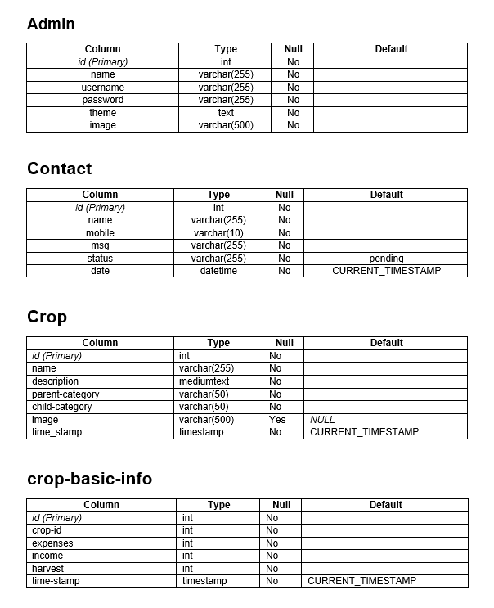**4.2 Data Dictionary**

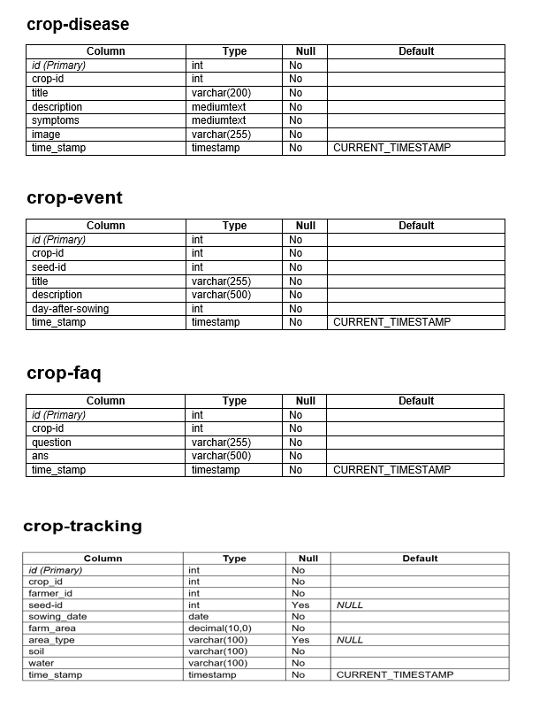

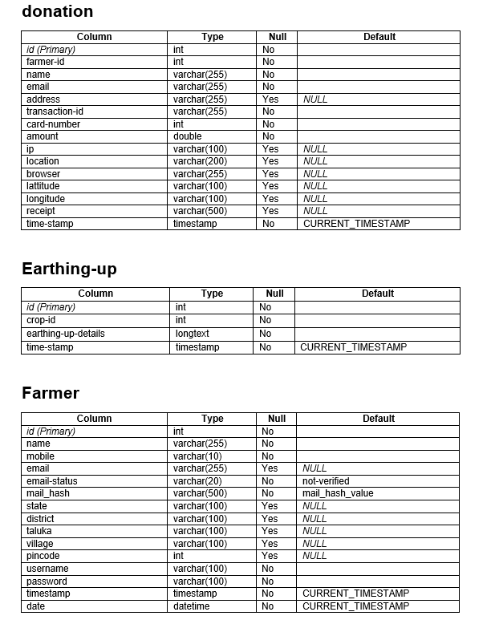

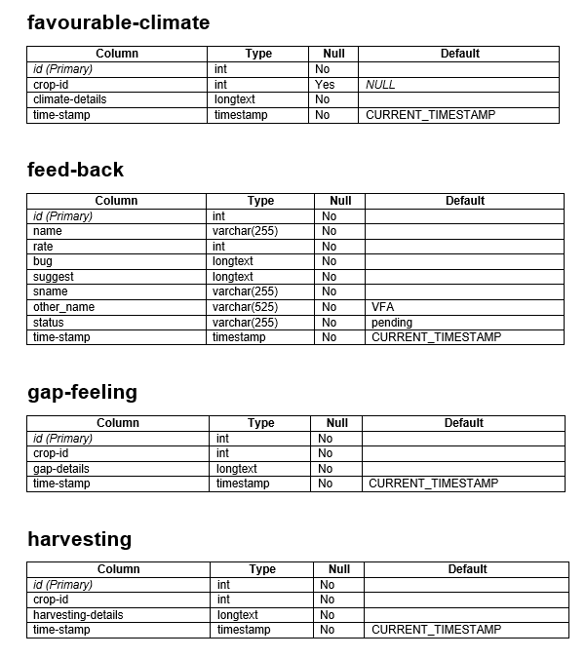

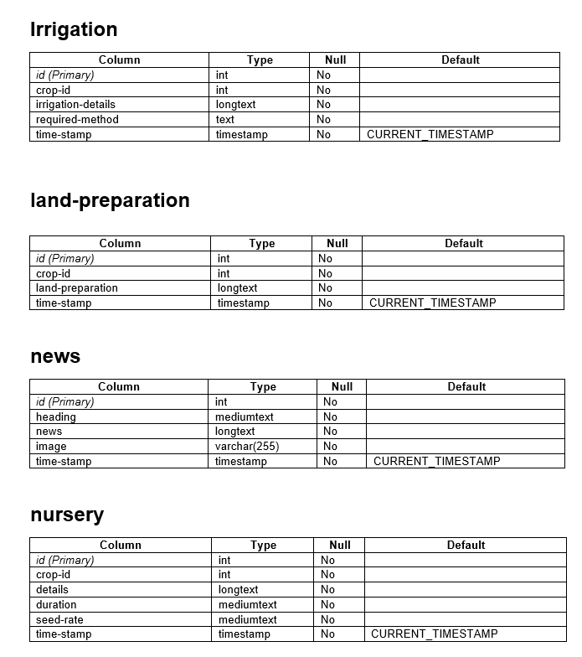

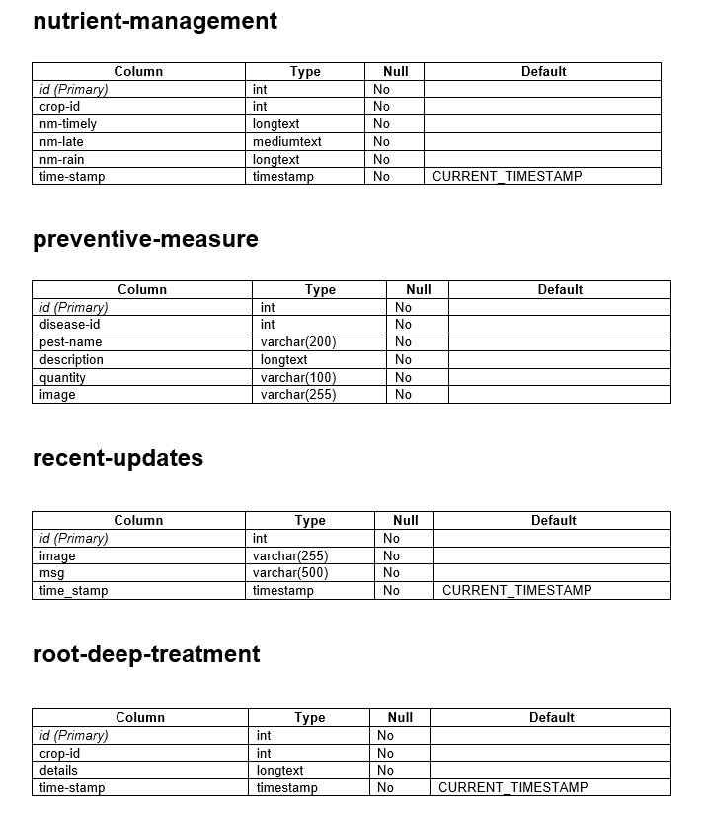

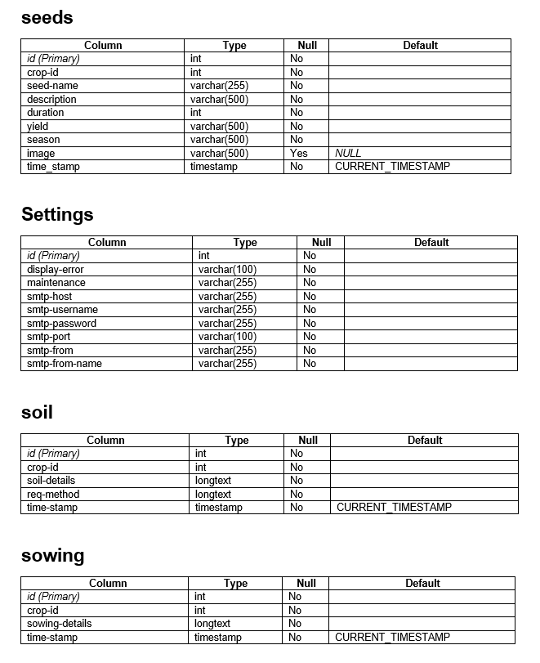

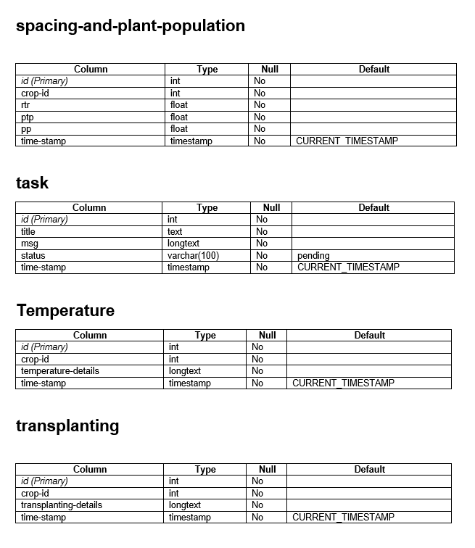

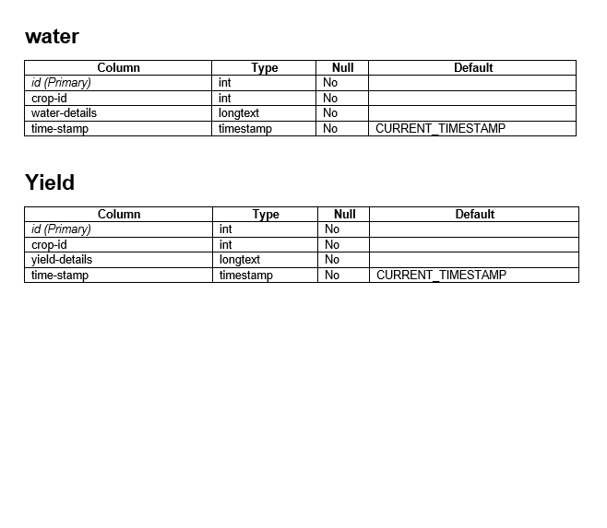

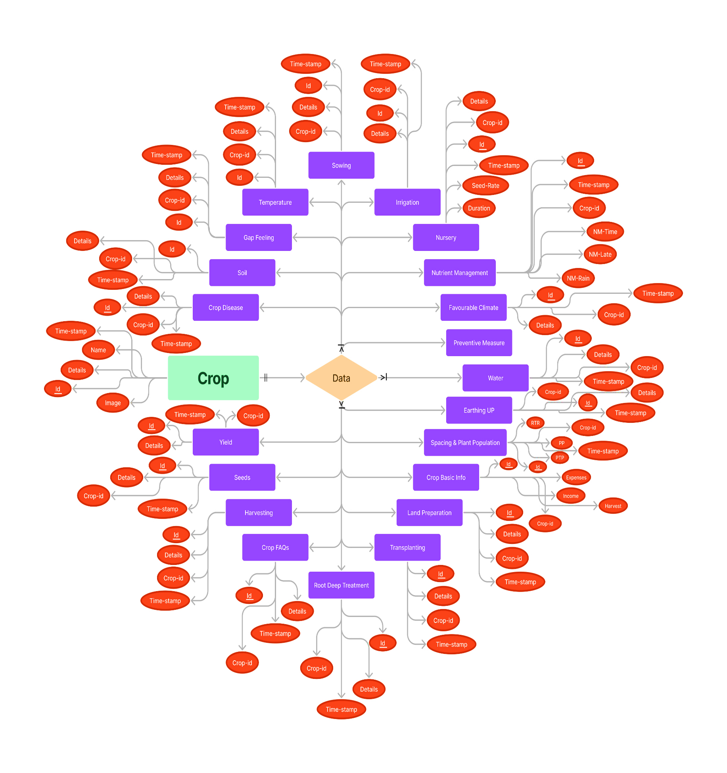**4.4 E-R Diagram**

* **E-R Diagram For Admin Side**
* 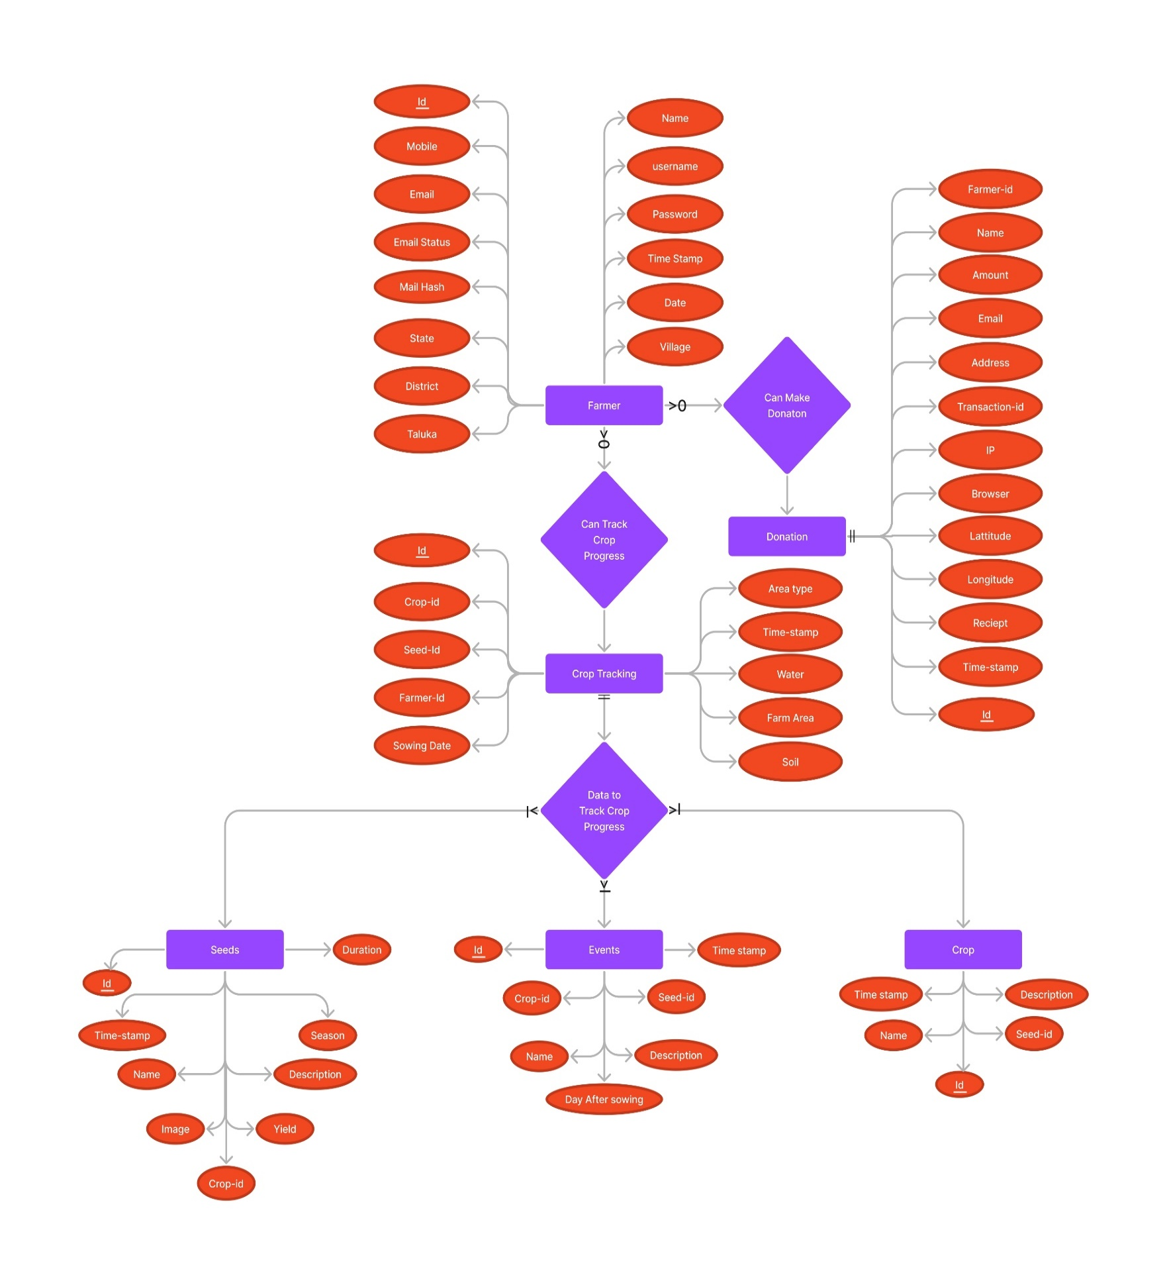 **E-R Diagram For User Side**

**4.5 Use-case Diagram**

* 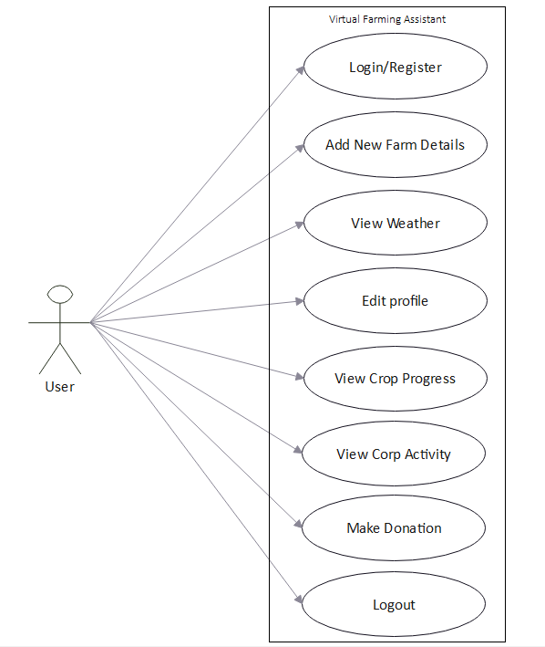 **Use-case Diagram For User Side**
* 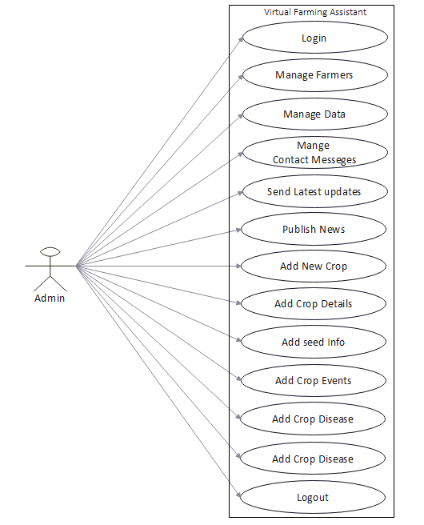 **Use-case Diagram For Admin Side**

**4.5 Gantt Chart**

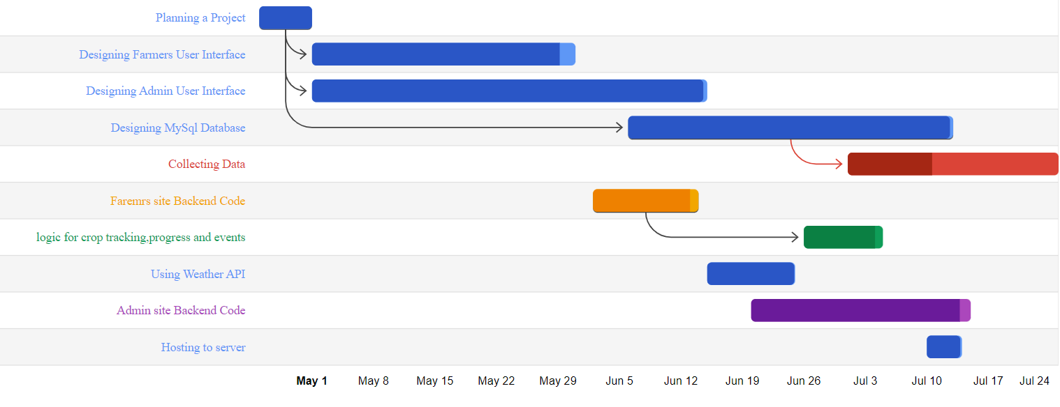

**CHAPTER 5**

**TEST CASES**

|  |  |  |  |  |  |
| --- | --- | --- | --- | --- | --- |
| Login Module | | | | | |
| TEST CASE No. 1 | | | TEST CASE DESIGN DATE :  6/August/2022 | | |
| TEST TITLE : Login Module Test | | | TEST CASE EXECUTION DATE :  7/August/2022 | | |
| DESCRIPTION : In this test case Login module would be tested | | | | | |
| PRECONDITION : Login Activity must be working | | | | | |
| STEP  No. | TEST STEP | TEST DATA | EXPECTED RESULT | ACTUAL RESULT | STATUS |
| 1 | Navigate to Login Page | Login Activity | Login Activity is  visible | Same As Expected | PASS |
| 2 | Enter Email | Hardik12 | Email is accepted | Invalid User Name | PASS |
| 3 | Enter Password | 123 | Password is accepted | Same As Expected | PASS |
| 4 | Click Login Button | Button Click | Check Credentials | Same As Expected | PASS |

|  |  |  |  |  |  |
| --- | --- | --- | --- | --- | --- |
| Signup Module | | | | | |
| TEST CASE No. 2 | | | TEST CASE DESIGN DATE :  4/August/2022 | | |
| TEST TITLE : Signup Module Test | | | TEST CASE EXECUTION DATE :  5/August/2022 | | |
| DESCRIPTION : In this test case Signup Activity would be tested | | | | | |
| PRECONDITION : Signup Activity must be working | | | | | |
| STEP  No. | TEST STEP | TEST DATA | EXPECTED RESULT | ACTUAL RESULT | STATUS |
| 1 | Navigate to Signup Activity | Signup Activity | Signup Activity is  visible | Same As Expected | PASS |
| 2 | Enter All Fields | Data | Check Data Integrity | Same As Expected | PASS |
| 3 | Click Signup Button | Button Click | Signup done  With all Validation | Same As Expected | PASS |

|  |  |  |  |  |  |
| --- | --- | --- | --- | --- | --- |
| Add Crop Module | | | | | |
| TEST CASE No. 3 | | | TEST CASE DESIGN DATE :  10/August/2022 | | |
| TEST TITLE : Add New Crop Module Test | | | TEST CASE EXECUTION DATE :  12/August/2022 | | |
| DESCRIPTION : In this test case crop tracking Activity would be tested | | | | | |
| PRECONDITION : login Activity must be working | | | | | |
| STEP  No. | TEST STEP | TEST DATA | EXPECTED RESULT | ACTUAL RESULT | STATUS |
| 1 | Navigate to Farmers Dashboard | Add New Crops | Crop module is  visible | Same As Expected | PASS |
| 2 | Enter All Fields | Data | Check Data Integrity | Same As Expected | PASS |
| 3 | Click Add Button | Button Click | Crop addition done with all Validation | Same As Expected | PASS |

**CHAPTER 6**

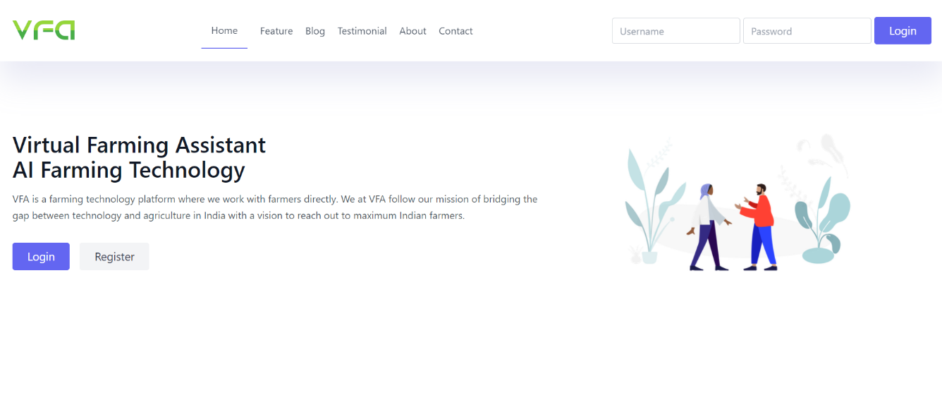 **SCREENSHOTS**

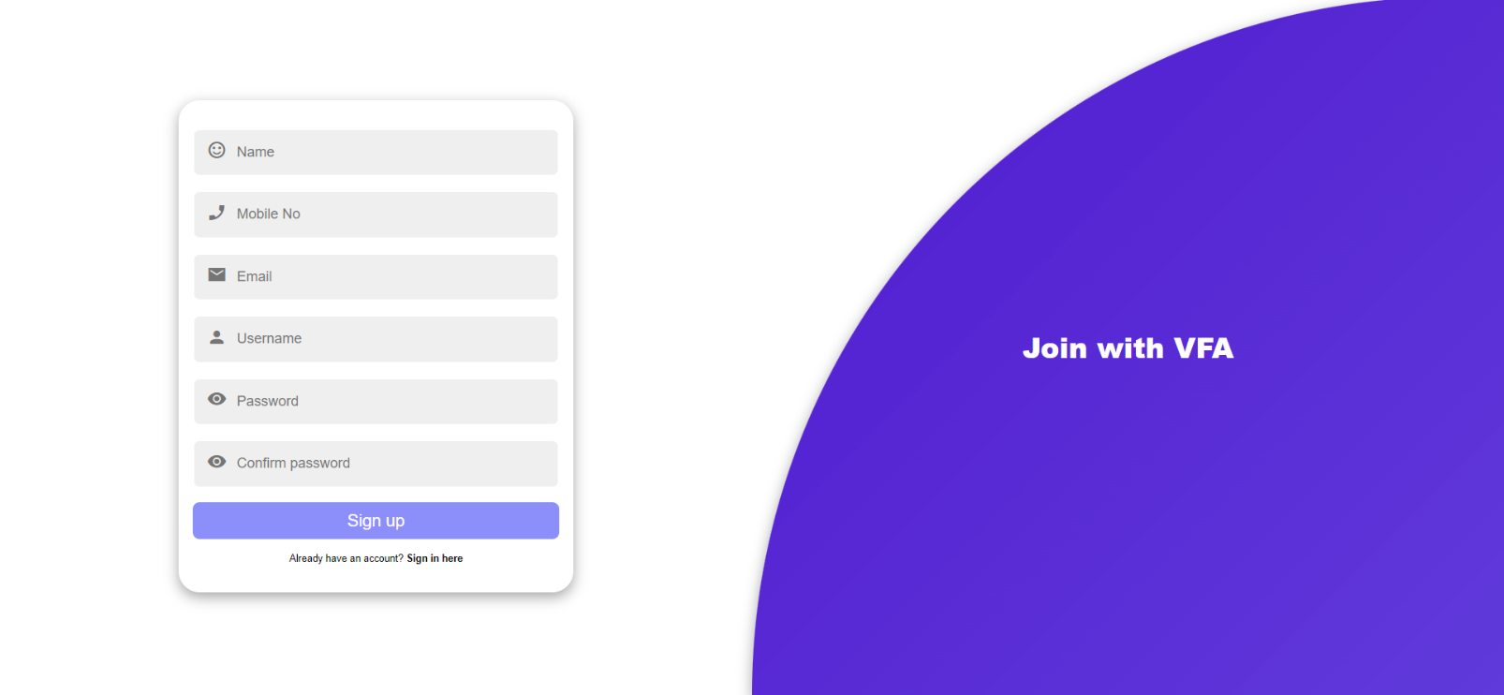

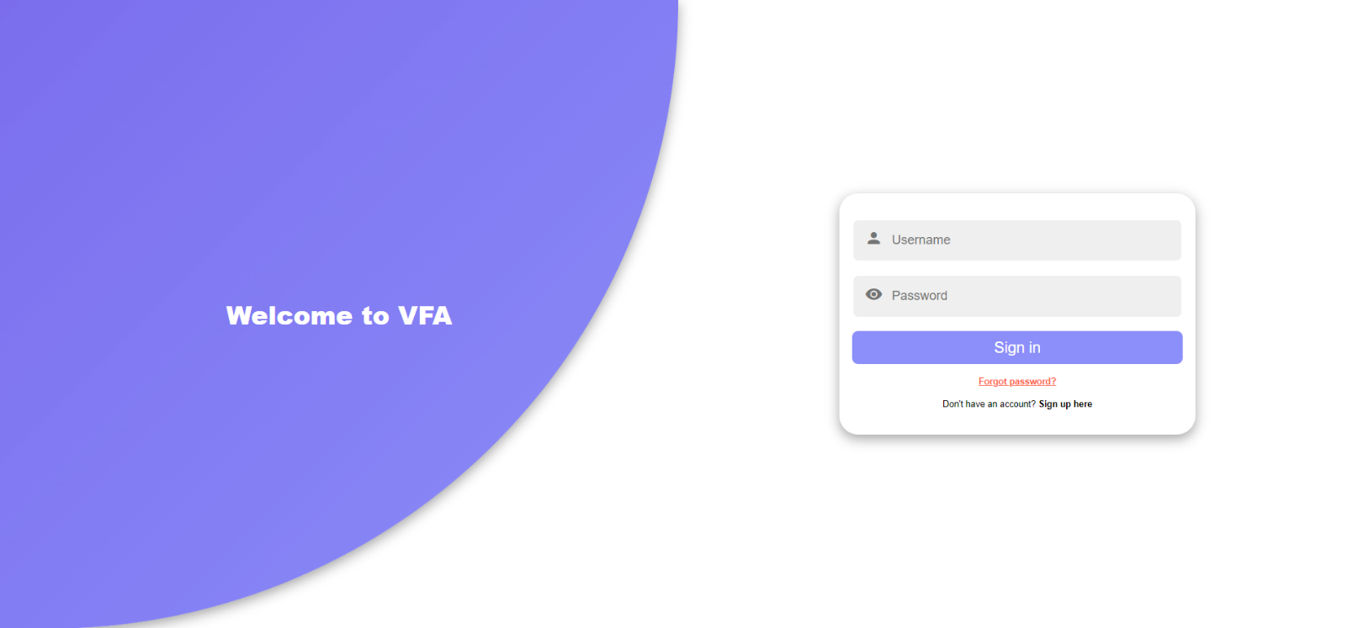

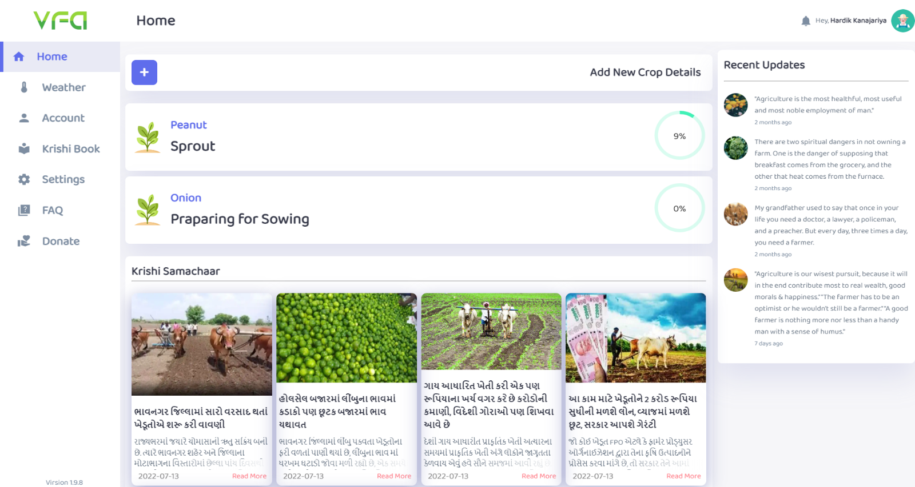

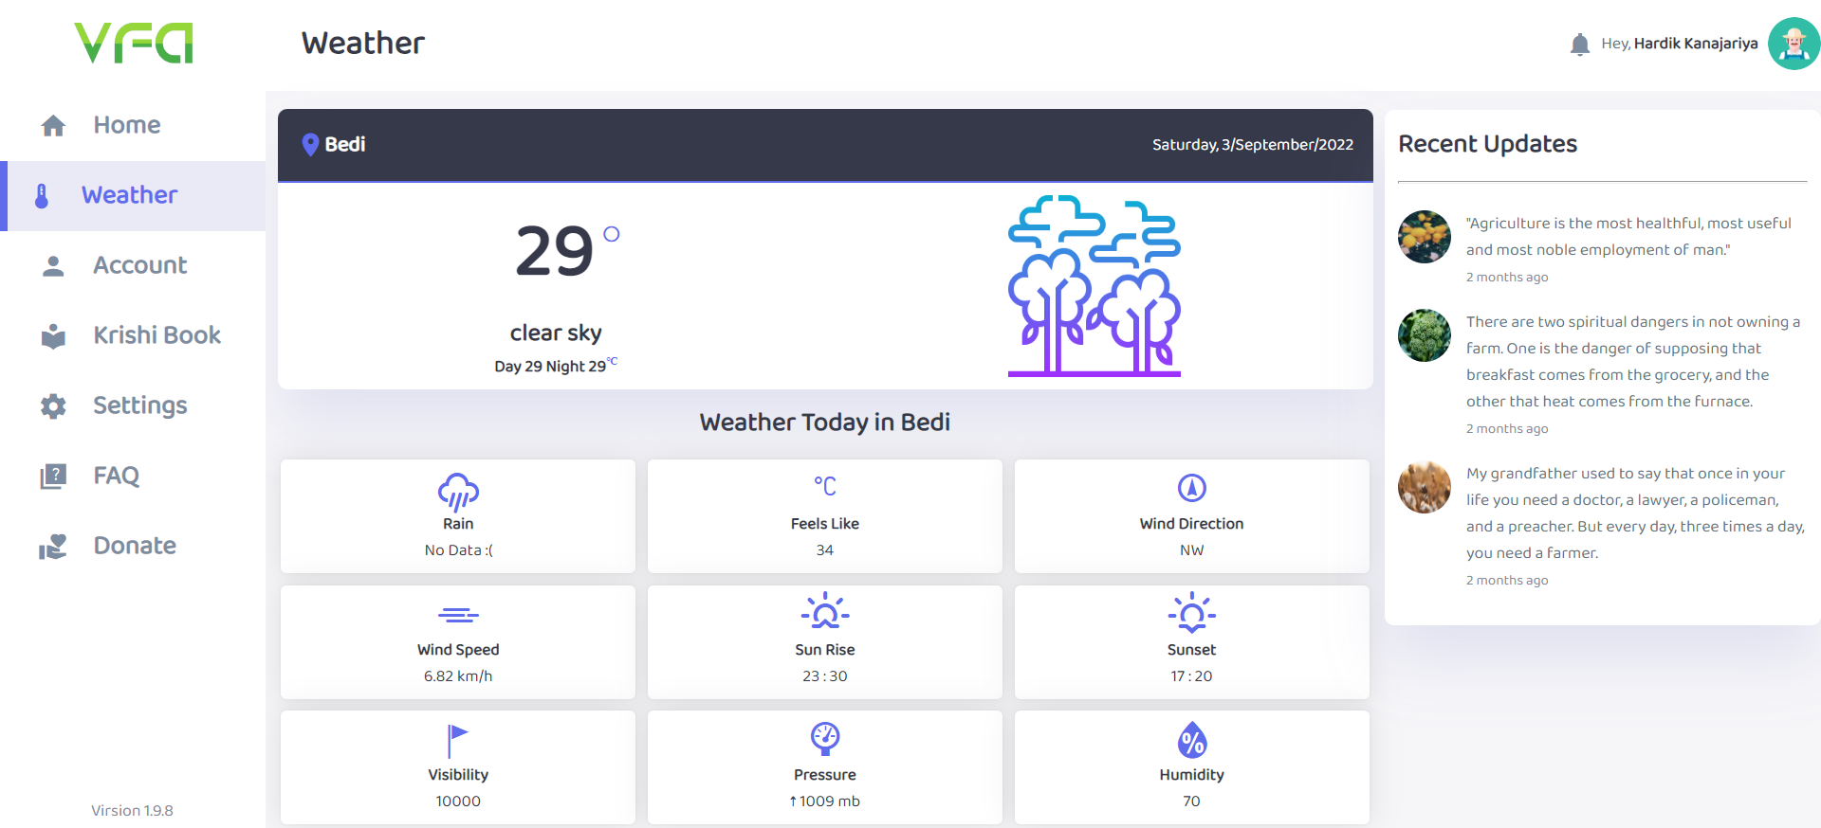

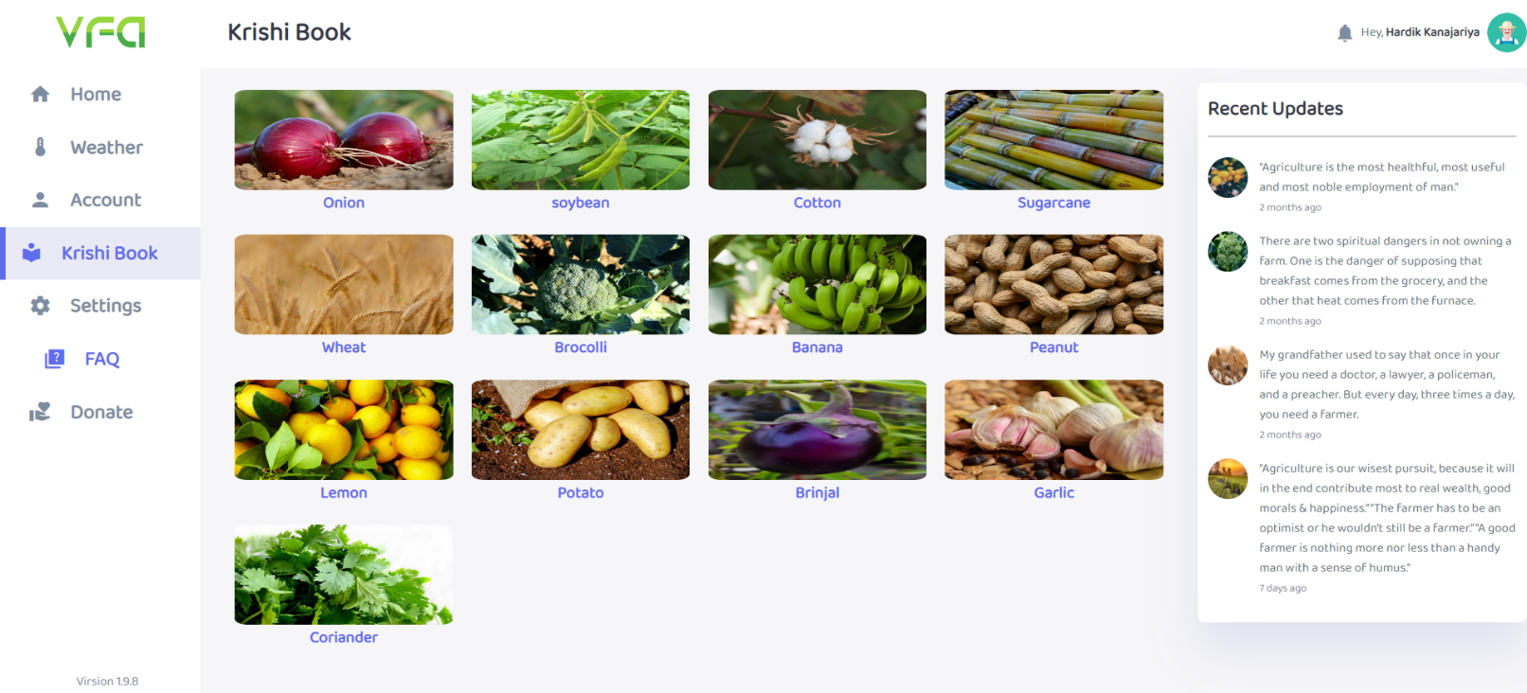

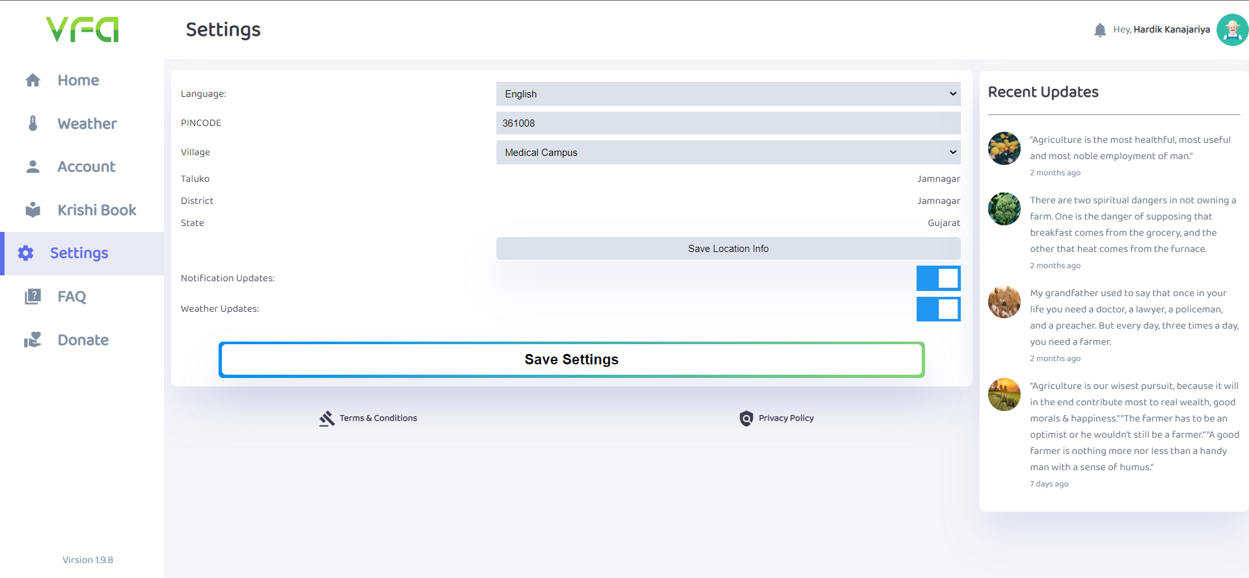

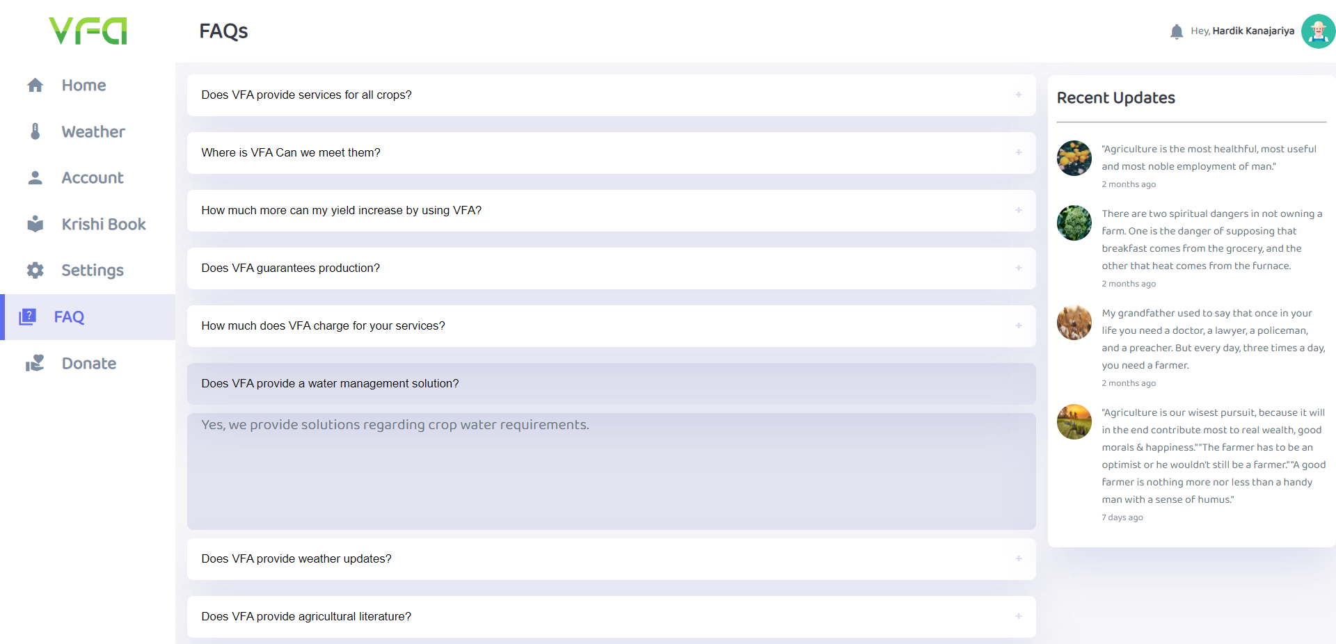

**CHAPTER 7**

**LIMITATIONS AND FUTURE ENHANCEMENTS**

* This project contains most useful services for Farmers. We have tried to include most of the required functionality in this project
* Additionally this application can be build up with other facilities and provide more services to the users of this application.
* Through online availability of this system, it can be access from anywhere.

**CHAPTER 8**

**CONCLUSION**

* The Main purpose of this web application is to Help farmers to track their Crop progress and get best yield from their fields

**Security:**

* Data is secure. Only the administrators can do high-privileged operations.

**Large Database support:**

* Using Microsoft SQL server means large of records can be managed without facing any problems.

**CHAPTER 9**

**REFERENCES AND BIBLIOGRAPHY**

**Books:**

1. [**https://www.w3schools.com**](https://www.w3schools.com)
2. [**https://stackoverflow.com**](https://stackoverflow.com)
3. [**https://www.youtube.com**](https://www.youtube.com)
4. [**https://www.google.com**](https://www.google.com)